**AUTOMATIC SHOPPING CART:**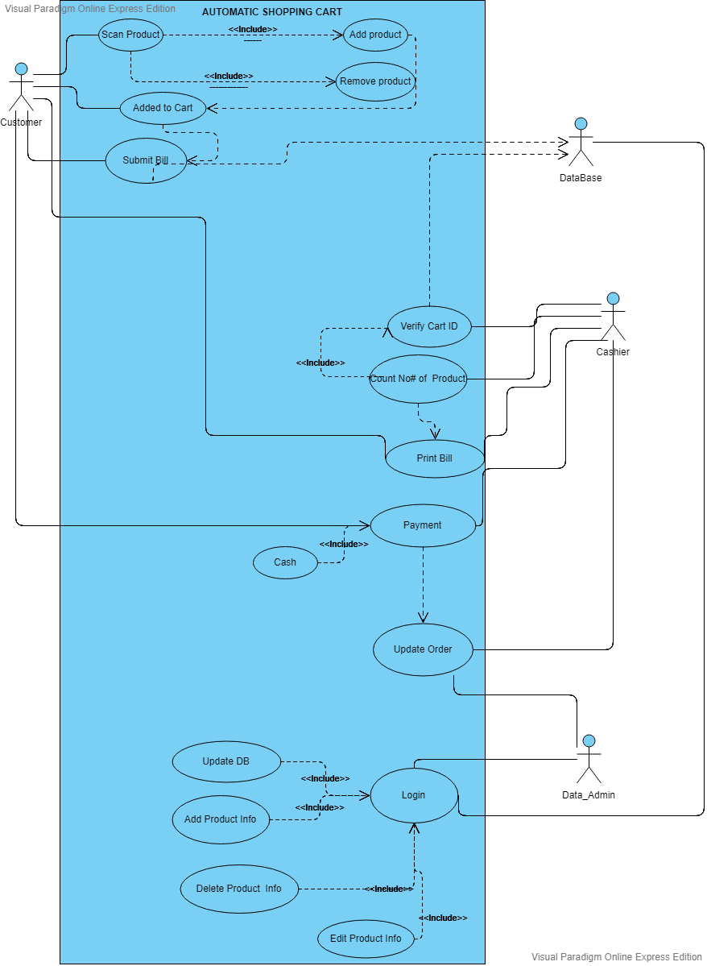

**Use Case Scenario1(Scan Product):**

|  |  |
| --- | --- |
| Actors: | : Customer |
| Use-Case: | : Scan Product |
| Pre-Condition: | :Take Cart with Cart ID |
| Description: | Customer need to scan the product to add product in the cart |

**Use Case Scenario2(Add Product):**

|  |  |
| --- | --- |
| Actors: | : Customer |
| Use-Case: | : Add Product |
| Pre-Condition: | : Scan Product |
| Description: | Customer need to scan the product to add product in the cart |

**Use Case Scenario3(Remove Product):**

|  |  |
| --- | --- |
| Actors: | : Customer |
| Use-Case: | : Remove Product |
| Pre-Condition: | : Scan product Again |
| Description: | Customer need to scan the product to remove product in the cart. |

**Use Case Scenario4(Added to Cart):**

|  |  |
| --- | --- |
| Actors: | : Customer |
| Use-Case: | : Added to Cart |
| Pre-Condition: | : Add product, Scan Product |
| Description: | Customer scans the product and product added/Remove from the Cart. |

**Use Case Scenario5(Submit Bill):**

|  |  |
| --- | --- |
| Actors: | : Customer, Data Base |
| Use-Case: | : Submit Bill |
| Pre-Condition: | : Added to Cart, Scan Product, Add Product |
| Description: | Customer will send the Data to DB with Cart ID and reach the bill counter. |

**Use Case Scenario6(Verify Cart ID):**

|  |  |
| --- | --- |
| Actors: | : Customer, Cashier |
| Use-Case: | : Verify Cart ID |
| Pre-Condition: | : Submit Bill |
| Description: | Customer need to provide Cart ID and the cashier will verify it and then count the product. |

**Use Case Scenario7(Print Bill):**

|  |  |
| --- | --- |
| Actors: | : Customer, Cashier |
| Use-Case: | : Print Bill |
| Pre-Condition: | : Verify Cart ID, Count the Number of Product |
| Description: | Customer will Have printed Bill with all the Details of product and Quantity and total amount. |

**Use Case Scenario8(Payment):**

|  |  |
| --- | --- |
| Actors: | : Customer, Cashier, Data Admin |
| Use-Case: | : Payment |
| Pre-Condition: | : Print Bill, verify Cart ID, Count # of Product |
| Description: | Customer will pay the amount and the cashier will receive the amount and update Order to  Data admin |

**Use Case Scenario9(Login):**

|  |  |
| --- | --- |
| Actors: | : Data admin, Data Base |
| Use-Case: | : Login |
| Pre-Condition: | : Enter username and password |
| Description: | Data admin need to enter username and password to Update Data Base and product Details. |

**Use Case Scenario10(Update Database):**

|  |  |
| --- | --- |
| Actors: | : Data admin, Data Base |
| Use-Case: | : Update Data Base |
| Pre-Condition: | : Login |
| Description: | Data admin need to enter username and password to Update Data Base. |

**Use Case Scenario11(Add Product Info):**

|  |  |
| --- | --- |
| Actors: | : Data admin, Data Base |
| Use-Case: | : Add product Info |
| Pre-Condition: | : Login |
| Description: | Data admin need to login to add product info in the Data base. |

**Use Case Scenario12(Delete Product Info):**

|  |  |
| --- | --- |
| Actors: | : Data admin, Data Base |
| Use-Case: | : Delete Product Info |
| Pre-Condition: | : Login |
| Description: | Data admin need to login to Delete Product info from Data Base. |

**Use Case Scenario13(Update Order):**

|  |  |
| --- | --- |
| Actors: | : Customer, Cashier, Data admin, Data Base |
| Use-Case: | : Update Order |
| Pre-Condition: | : Payment, |
| Description: | After payment of Customer with Associated Cart ID and after payment is received the cashier will be updating the Data Admin about the Order. |

**Use Case Scenario14(Edit Product info):**

|  |  |
| --- | --- |
| Actors: | : Customer, Cashier, Data admin, Data Base |
| Use-Case: | : Edit Product Info |
| Pre-Condition: | : Login |
| Description: | If the product information need to be changed the data admin need to login to Database to Edit the product information/details. |